Option 2: Social Determinants of Health in Washington State

Introduction

The research question I am answering is **How does the distribution of elderly people in poverty compare with the location of long-term nursing home facilities in King County?** I first decided to explore this topic when I observed the range of data and layers on the Washington department of health’s interactive map app. Across the state, there was clear indicators of where areas had higher rates of poverty. However, in the King County area, it was difficult to distinguish which census tracts were more sever given their size. The other aspect I explored was long-term care nursing homes. These facilities are for the people age 65 and over who need assistance with daily tasks or have medical conditions that need additional assistance that cannot attend to on their own. Although these facilities are beneficial in helping the elderly, these facilities lack accessibility as they are expensive. According to the organization Senior Living, the average cost of care for a resident in a nursing home in Washington state is 9,581. This made me think about how this would affect the elderly population in poverty who possibly need long-term care assistance but cannot receive it. How accessible are these facilities? Would an elderly person in poverty be able to go to one of these facilities if they were in need? Through GIS analysis, we look to uncover the answers to these questions in hopes of aiding this underrepresented group.

Methodology

The first step to answering this question was in the form of downloading the data from the poverty data from the Washington department of health website. The data was able to be downloaded in a csv format in which I was able to upload into QGIS. I also gathered various shapefiles of Washington so that geographical units are joined with attribute units. Some of the shapefiles I used were Census Tracts, King County Council, and Washington State Legislature.The poverty attribute data I collected from the Wahsinton Department of Health site already had Census Tract. So, I used this as a unique identifier to join the table to the census tract shapefile. The next action I did was to bring in census data from used in the previous labs (lab 6) to get the population of people in King County that were over the age of 65. I also joined this table to the census tracts shapefile but with using the unique identifier of GeoID. Next, I made sure the columns I was planning to use (poverty rate, and population over 65) were in the correct data type and format. I used the field calculator to create new columns to change the poverty rate from string to numerical so that it was in decimals. I also found the proportion of people 65 and over by dividing the total people 65 and older by the total population in King county. This then allowed me to multiply the rate of poverty by the proportion of people age 65 and over by the total population to get the number of people across King county who satisfied those dimensions. I was able to map out the locations of these individuals using a dot density layer. The next task I did was importing secondary data from the Washington Geospatial open data source. This is where I found the long-term care nursing home data which was in a shapefile. This allowed me to easily import this layer to map out the nursing home locations. Lastly for analysis I created a 5 mile buffer to measure the relative distance elderly in poverty are to these nursing home facilities. I also used an intersection overlay to discover the number of individuals that fit within this buffer.

Results

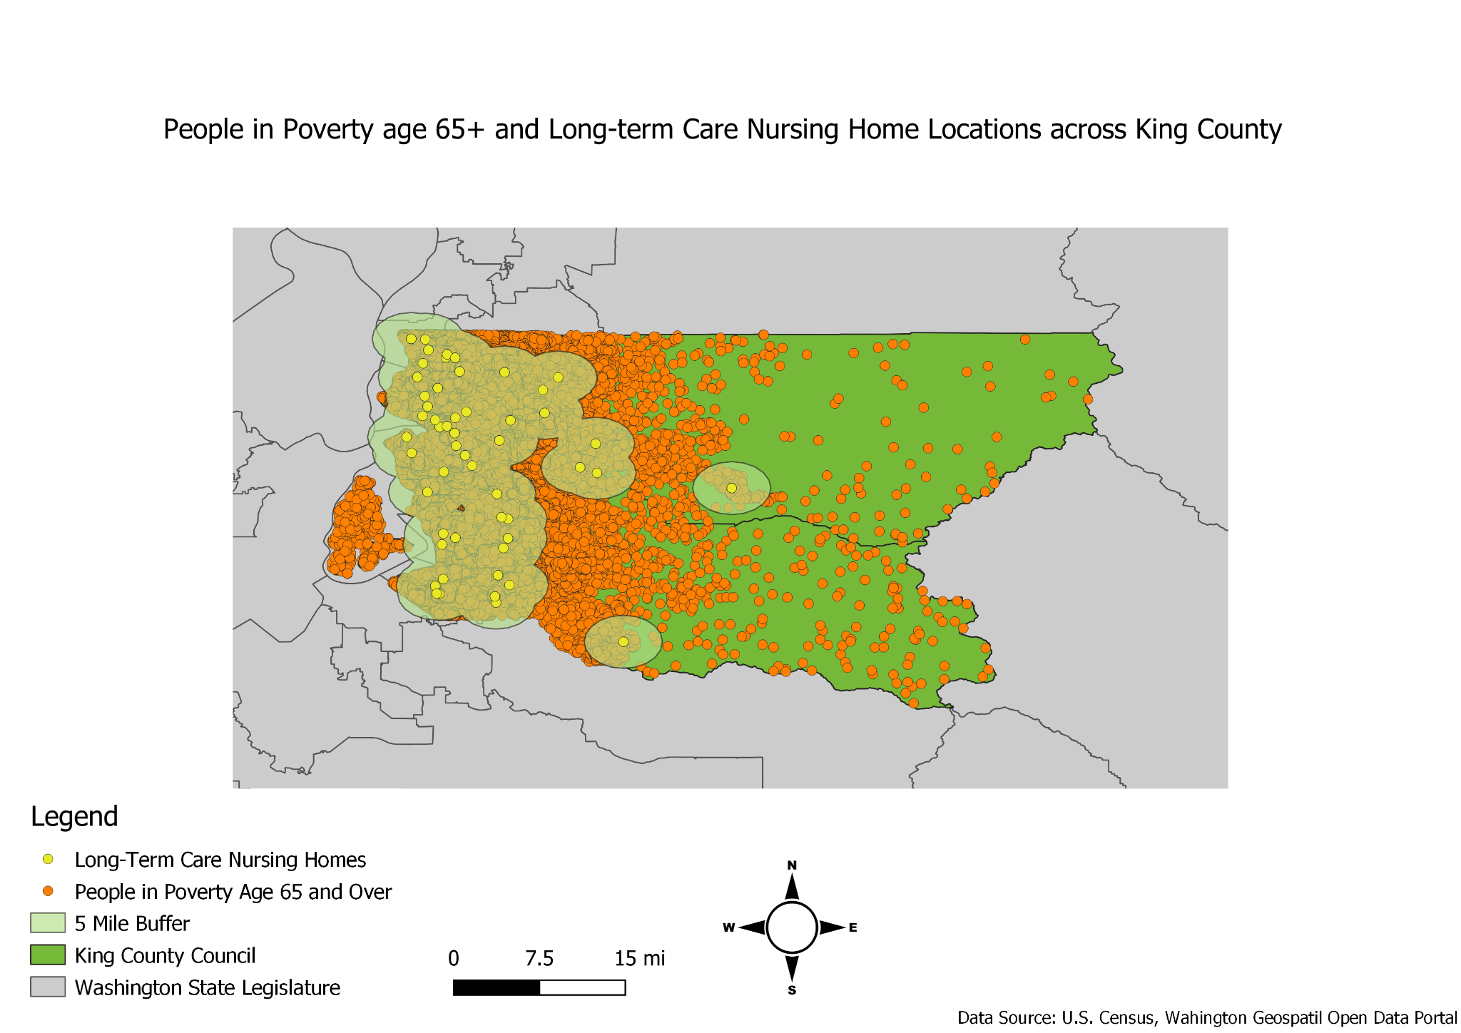

The findings from this map indicate that about 92% of people age 65 and over live within 5 miles of a long-term nursing home facility. Additionally, it can be observed that there is a correlation between the location of the majority of these nursing home facilities and the distribution of elderly people which are on the west side of the county. However, this causes somewhat of a geographic disparity as there seems to be a significant lack of facilities on the east side of the state. Another cause for concern is that the majority of these nursing homes are close together and overlap buffers. This means that those in the central and southeast part of the counties have even less accessibility to these locations. Given that these individuals are in need long term care and are possibly unable to drive, this is significant as those who are not near a facilty may be unable receive the care they need. By comparing the location of these facilities and elderly people, it highlights the disparities across the county that should be addressed by the state government and king county officials. While the results do not solve the issue of obtaining funds for elderly people in poverty, this map reflects a need for more evenly distributed health resources that would aid elderly populations in poverty that potentially need long-term care.

References:

<https://www.seniorliving.org/nursing-homes/costs/>

<https://fortress.wa.gov/doh/wtn/WTNIBL/>